ECOPact is the industry’s broadest range of low-carbon concrete for high-performing and sustainable construction. ECOPact features a range of low-carbon levels, from 30% to 100% less carbon emissions compared to standard (OPC) concrete. ECOPact can be used in any type of applications, regardless of performance requirements: from foundations, columns and beams, to walls, driveways and walkways. ECOPact is available in a variety of strength classes and is compliant with industry standards. It can be handled, pumped and finished like conventional concrete.
In accordance with the sustainability targets of your project, the engineer can either specify a desired percentage of Global Warming Potential (GWP) reduction compared to a regional baseline, or indicate a maximum GWP value per class of concrete mix. As a solutions provider, our concrete experts can help find out the GWP targets that can be achieved for any given strength and durability requirement.
The GWP value of each ECOPact mix is scientifically calculated and third-party verified. The outcome is summarized in a product specific Environmental Product Declaration (EPD) that is part of the ECOPact solution and will be provided with each mix.
This specification language can be included into the project specifications. Below is the typical list of contents in specifications for Cast-in-place concrete. ECOPact specification language should be inserted in the sections identified in green bold font. These sections are pertinent to low-carbon concrete.
This specification is provided as a courtesy on an as-is basis, and is not intended to substitute for specific design services provided by an architect, engineer, or other design professional. Text underlined and/or red in color must be addressed to complete a final specification document. It is the sole responsibility of the editor to exercise appropriate care and sound professional judgment in the execution of this task.
For more information, contact Holcim (US), 8700 West Bryn Mawr Ave., #300, Chicago, IL 60631; Phone (888) 646-5246; Website: www.holcim.com/ecopact; Email: ask@holcim.com.

CONTENTS

PART 1 – GENERAL 3
1.1 RELATED DOCUMENTS 3
1.2 SUMMARY 3
1.3 DEFINITIONS 3
1.4 PREINSTALLATION MEETINGS 3
1.5 SUBMITTALS 3
1.6 QUALITY ASSURANCE 4
1.7 DELIVERY, STORAGE & HANDLING 4
1.8 FIELD CONDITIONS 4
PART 2 – PRODUCTS 4
2.1 CONCRETE MATERIALS 4
2.2 FIBER REINFORCEMENT 4
2.3 VAPOR RETARDERS 4
2.4 FLOOR AND SLAB TREATMENT 4
2.5 LIQUID FLOOR TREATMENTS 4
2.6 CURING MATERIALS 4
2.7 RELATED MATERIALS 4
2.8 REPAIR MATERIALS 4
2.9 CONCRETE MIXTURES, GENERAL 5
2.10 CONCRETE MIXTURES 6
2.11 CONCRETE MIXING 8
PART 3 – EXECUTION 8

PART 1 – GENERAL

RELATED DOCUMENTS

SUMMARY

DEFINITIONS

PREINSTALLATION MEETINGS

SUBMITTALS

Product Data

Sustainable Design Submittals

- Environmental Product Declaration (EPD): Product-specific third-party verified Type III environmental product declaration is required for each mix, for at least 90% by volume or cost of the concrete on the project within 18 months of bid award. EPD must state conformance to ISO 14025 and EN 15804 or ISO 21930, and have at least a cradle-to-gate scope.

- OPTIONAL: LEED Recycled content: Submit product data and certification letter from product manufacturers, indicating percentages by weight of postconsumer and preconsumer recycled content for each concrete mix.

- OPTIONAL: LEED multi-attribute optimization: Product-specific Type III environmental product declaration is required for each mix, for at least 90% by volume or cost of the concrete on the project within 18 months of bid award. EPD must state conformance to ISO 14025 and EN 15804 or ISO 21930, and have at least a cradle-to-gate scope. EPD must demonstrate impact reduction below industry average in at least three of the following categories:
  - global warming potential (greenhouse gases), in CO2e;
  - depletion of the stratospheric ozone layer, in kg CFC-11;
  - acidification of land and water sources, in moles H+ or kg SO2;
  - eutrophication, in kg nitrogen or kg phosphate;
  - formation of tropospheric ozone, in kg NOx, kg O3 eq, or kg ethene; and
  - depletion of nonrenewable energy resources, in MJ.
For products meeting the above criteria, submit a letter stating the dollar value of all products that are extracted, manufactured, and purchased (including distribution) within a 100 mile radius of the project site.

Design mixtures

Shop drawings

QUALITY ASSURANCE

DELIVERY, STORAGE & HANDLING

FIELD CONDITIONS

PART 2 – PRODUCTS

CONCRETE MATERIALS

CEMENTITIOUS MATERIALS

- Portland and blended-hydraulic cement: ASTM C150, ASTM C595, or ASTM C1157
- Fly Ash: ASTM C618, Class C or F.
- Slag Cement: ASTM C989/C989M.
- Silica Fume: ASTM C1240 anamorphous silica.
- Metakaolin: ASTM C618, Class N.

NORMAL WEIGHT AGGREGATES

LIGHTWEIGHT AGGREGATES

AIR ENTRAINING ADMIXTURES

CHEMICAL ADMIXTURES

WATER

FIBER REINFORCEMENT

VAPOR RETARDERS

FLOOR AND SLAB TREATMENT

LIQUID FLOOR TREATMENTS

CURING MATERIALS

RELATED MATERIALS

REPAIR MATERIALS

CONCRETE MIXTURES, GENERAL
These specification inserts are performance based. This allows the concrete manufacturer to optimize each ECOPact mix design in order to reach the required strength and durability requirements. At the same time the use of raw materials will be optimized, thus leading to maximal GWP reduction. The engineer should minimize prescriptive requirements on concrete mixtures and construction means and methods and increase the focus on measurable performance attributes when appropriate. The inclusion of both prescriptive and performance requirements in the specification can lead to inherent conflicts.

DESIGN & TESTING

Basis-of-Design Product: Subject to compliance with requirements, provide Holcim (US) ECOPact or comparable product.

Prepare design mixtures for each type and strength of concrete, proportioned on the basis of laboratory trial mixture or field test data, or both, according to ACI 301.

CEMENTITIOUS MATERIALS
In order to best leverage the available regional SCM and optimize the embodied carbon content of ECOPact mixes, it is preferable not to limit the percentage of cementitious materials other than Portland cement (Option 1). However, if there is a particular project requirement, use Option 2 limits to allow for the entire ECOPact range of low-carbon mixes.

Option 1 (Preferred): Do not limit percentage of cementitious materials other than Portland cement unless there is a particular requirement in local building codes.

Option 2: Limit percentage, by weight, of cementitious materials other than Portland cement in concrete as follows:
1. Fly Ash or Other Pozzolans: 50 percent by mass.
2. Slag Cement: 80 percent by mass.
3. Silica Fume: 15 percent by mass.
4. Total of Fly Ash or Other Pozzolans, Slag Cement, and Silica Fume: 70 percent by mass, with fly ash or pozzolans not exceeding 50 percent by mass and silica fume not exceeding 10 percent by mass.
5. Total of Fly Ash or Other Pozzolans and Silica Fume: 60 percent by mass with fly ash or
pozzolans not exceeding 50 percent by mass and silica fume not exceeding 10 percent by mass.

ADMIXTURES

CONCRETE MIXTURES
Maximum GWP allowances per mix can be addressed by two different approaches:
Option 1: Require a reduction percentage for the total GWP of the project’s concrete mixes, compared to the regional industry average based on NRMCA table
Option 2: Limit the GWP of each mix to a given value. This value can be derived from a whole-building Life Cycle Analysis depending on the GWP reduction targets of the project, or by comparison with standard mixes with equivalent strength and properties.

Maximum global warming potential (GWP):
OPTION 1: GWP reduction compared to NRMCA regional industry averages
Total GWP of the concrete supplied for the building shall be at least [insert%] % lower on a volume-weighted basis, than the amount of GWP using NRMCA industry averages based on strength and weight class for each mix. GWP reduction shall be validated through product-specific Environmental Product Declarations for each mix.
Acceptable product: ECOPact by Holcim (US) or comparable product.
The aggregate reduction is calculated as follows:

$$Reduction=100\%-\frac{\sum{}{GWP}_{a,mix}*V_{mix}}{\sum{}{GWP}_{b,mix}*V_{mix}}*100\%$$

Where
- ${GWP}_{a,mix}$: actual GWP value of the mix as per product-specific EPD
- ${GWP}_{b,mix}$: baseline GWP value of the mix based on NRMCA regional averages (see table below)
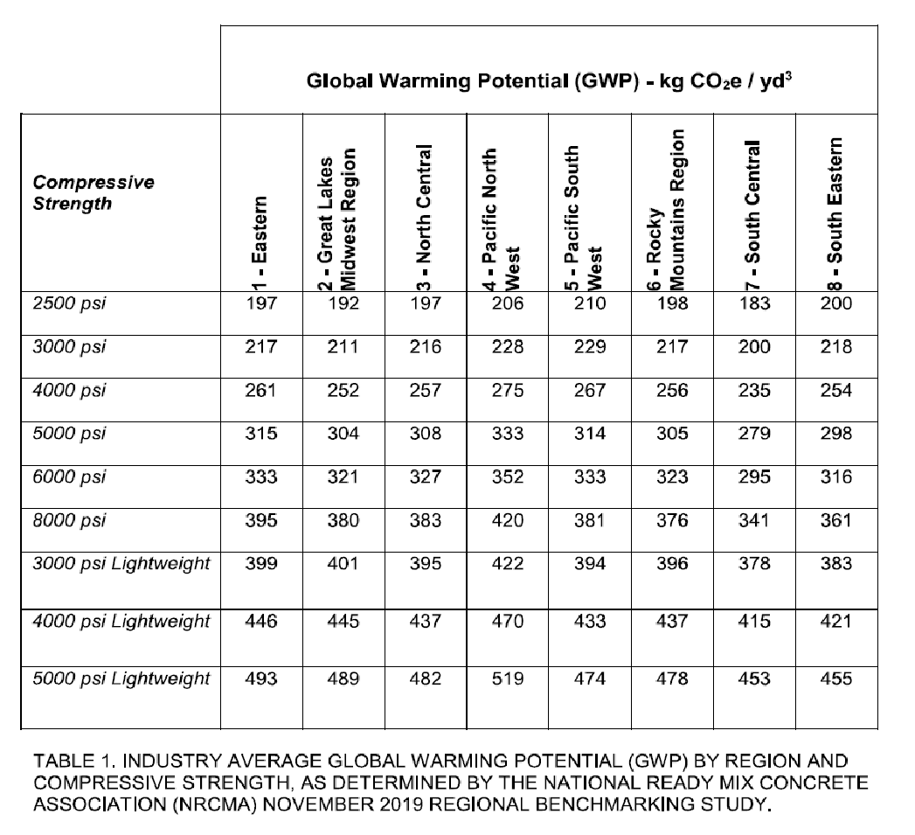

Use the following performance criteria for each class of concrete mixture. Ensure that the specified strength is consistent with the most restrictive requirement governed by structural design and the applicable exposure class for each class of concrete. If GWP Option 1 is not selected, use GWP Option 2: Include a maximum GWP value per class of mix. If GWP Option 1 is preferred, remove GWP criteria from all concrete mix classes.
    - [Class A i.e. pile caps, ground slab, etc.]: Basis of design product: Subject to compliance with requirements, provide Holcim (US) ECOPact or comparable product. Proportion normal-weight concrete mixture as follows:
- Minimum Compressive Strength (f’c): [xxxx] psi at [xx] days.
- Exposure class: [xx xx xx] - in accordance with ACI 318-14
- Maximum Aggregate Size: [xxx] inch
- Slump limit: to be selected by Contractor based on ASTM C143, as permitted under ACI 301
- [GWP Option 2] Maximum GWP: [xxx] kg eq CO2 / [cy or m3]

    - [Class B i.e. pile caps, ground slab, etc.]: Basis of design product: Subject to compliance with requirements, provide Holcim (US); ECOPact or comparable product. Proportion normal-weight concrete mixture as follows:
- Minimum Compressive Strength (f’c): [xxxx] psi at [xx] days.
- Exposure class: [xx xx xx] - in accordance with ACI 318-14
- Maximum Aggregate Size: [xxx] inch
- Slump limit: to be selected by Contractor based on ASTM C143, as permitted under ACI 301
- [GWP Option 2] Maximum GWP: [xxx] kg eq CO2/[cy or m3]

    - [Class C i.e. interior suspended lightweight slabs etc.]: Basis of design product: Subject to compliance with requirements, provide Holcim (US); ECOPact or comparable product. Proportion lightweight concrete mixture as follows:
- Minimum Compressive Strength (f’c): [xxxx] psi at [xx] days.
- Exposure class: [xx xx xx] - in accordance with ACI 318-14
- Calculated Equilibrium Unit Weight: [xxxx] lb/cu.ft, plus or minus [xxxx] lb/cu.ft as determined by ASTM C567/C567M.
- Maximum Aggregate Size: [xxx] inch
- Slump limit: to be selected by Contractor based on ASTM C143, as permitted under ACI 301
- [GWP Option 2] Maximum GWP: [xxx] kg eq CO2/[cy or m3]

Refer to Appendix A for the definition of Exposure Classes and Requirements for Concrete in accordance with ACI 318-14.

CONCRETE MIXING

PART 3 – EXECUTION

END OF SECTION

For clarity, it is recommended to include APPENDIX A at the end of the specifications, as the contractor may not be familiar with code defined exposure classes and requirements.

APPENDIX A
Definition of Exposure Classes and Requirements for Concrete in accordance with ACI 318-14

